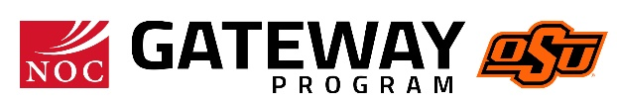
Name
Position/Title
Northern Oklahoma College
615 N. Monroe
Stillwater, OK 74078
Phone: 580.123.1234
Fax: 580.123.1234
yourname@noc.edu
www.noc.edu

