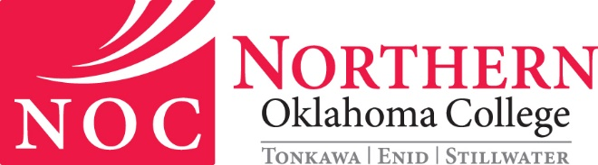
SCHOLARSHIP APPEAL FORM

Please complete both sides of this form and attach all pertinent documentation. Return to the Scholarship Office at the NOC campus you are attending.

NAME: __________________________________ SSN: _________________________
LOCAL ADDRESS: ____________________________________________________________
CITY: ___________________________ STATE: ___________________ ZIP CODE: _______
PHONE NUMBER: ___________________________________

Northern Oklahoma College values the well-being of our students and recognizes its responsibility to prepare them to contribute positively to society. To be considered for scholarships, applicants must adhere to the academic standards policies as well as the drug and student conduct policies of the institution as defined in the institutional catalog and student handbook – Guide to Student Rights and Responsibilities. Failure to comply may result in removal of scholarship award.

In the section below, please give an explanation of the circumstances that played a role in not meeting the required academic standards policies as well as the drug and student conduct policies of the institution. You must include additional documentation that supports the appeal.
______________________________________________________________________________
______________________________________________________________________________
______________________________________________________________________________
______________________________________________________________________________
______________________________________________________________________________
______________________________________________________________________________
______________________________________________________________________________
______________________________________________________________________________
______________________________________________________________________________
______________________________________________________________________________
In the section below, please explain what has changed in your previous circumstances that will allow you to improve next semester and be in compliance with the institutional policies if the committee approves this appeal.
______________________________________________________________________________
______________________________________________________________________________
______________________________________________________________________________
______________________________________________________________________________
______________________________________________________________________________
______________________________________________________________________________
______________________________________________________________________________
______________________________________________________________________________
______________________________________________________________________________
______________________________________________________________________________

I fully understand should this appeal be granted, I will be placed on probation for the semester and that I must bring myself into compliance with NOC’s policies. If I fail to do so, I understand that I will lose my eligibility for scholarship aid at Northern Oklahoma College.
I also understand that I am responsible for payment of the enrollment costs for the hours in which I am currently enrolled regardless of the outcome of the appeal.
By signing this form, I am declaring that everything I have stated is true. In addition, any documentation included is correct to the best of my knowledge. Should the committee find any documentation included in this appeal to be false, I understand that my appeal will be denied.

Student’s Signature: __________________________________ Date: _____________________

